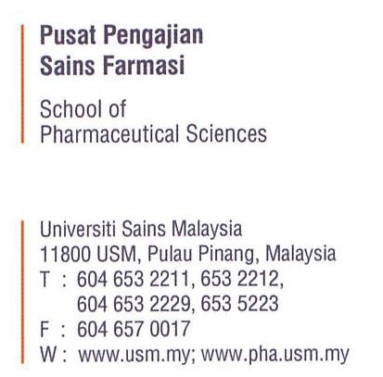


Date:

____________________________
____________________________
____________________________
E:__________________________
T: _________________________

Dear Sir/Madam,
APPOINTMENT AS _________________________________ FOR THE PROJECT ________________________________________________________

2. We are pleased to inform you that you have been identified for appointment as ________________________________ for the Project ____________________________ for the period from _________to _____. During this period, you will receive an honorarium of RM__________ per day/month/year/semester.
3. The job description is as follows:
3.1 .............................
3.2 .............................
3.3 .............................
4. If you have further enquiries regarding this matter, you may contact the person-in-charge: ______________________________________ via email _______________ or phone number _____________________________.
5. Attached to this letter of appointment is a reply form for further action. This form must be returned to the person-in-charge within seven (7) days from the date of this letter.

Thank you.

Yours sincerely,
.................................................................................
NAME:
POSITION:

..................................................................................................................................................................
For Office use only

APPROVED NOT APPROVED

.................................................................................
Prof Madya Dr. Nurzalina Abdul Karim Khan
Dean

REPLY FORM

Date:

Dean
School of Pharmaceutical Sciences
Universiti Sains Malaysia
11800 Pulau Pinang (Attn: Name of PIC)

Dear Sir/Madam,
APPOINTMENT AS _________________________________ FOR THE PROJECT ________________________________________________________

I hereby refer to my personal information as detailed below and *agree / do not agree to accept the appointment as ______________________ for the Project entitled_____________________________________________________________ for the period from _______________ to _____, with an honorarium of RM__________ per day/month/year/semester.

Full Name (as per IC/Passport) :
IC/Passport Number :
Organization/Institution/School :
Bank Account Number :
Bank Name :

Thank you.
Yours sincerely,

…………………………
(Signature)
Date :
*cross out where not applicable

